**Read me**

1. Used python 2.7 version for developing the project.
2. Python 2.7 is to be installed (<https://www.python.org/downloads/> )
3. Class Path for Python to be set.
4. Web browser like Chrome/Firefox/Internet explorer to be installed in the system.
5. Packages like sys,thread and socket are to be present to be imported for running the program.
6. One can select the port number of one's choice or if not specified, it takes the port number 9090 by default and IP address of the server (localhost (127.0.0.1)) are configured for the program.
7. After successful compilation of the program(Server.py) , run in the command line window (cmd.exe) as [python Server.py [portNumber]]
8. If an invalid port number is provided as an argument the program should throw an error.
9. If program runs successfully without any error a message will be displayed saying, 'Server is ready to receive request on port : ',portNumber
10. Open any of the browsers and enter the server localhost along with port number and webpage as below

<http://localhost:9090/blog.com>

Alternatively, one can make the proxy settings for a browser and use the link as below

<http://blog.com>

1. For the first time the page should display its contents.
2. On second time execution of the same page the cached file content should be displayed even if the system is not connected to the Internet.
3. Open other browser in parallel and request for another webpage the proxy server should accept the connection and display the web contents.(This shows multithreading)
4. Open a webpage whose web address/url is not proper or not valid an error page or appropriate error message will be displayed.
5. Code has been tested for following sites,

blog.com, yahoo.com, ndtv.com, cnn.com, espn.com etc.

**System Requirements:**Mfg Minimum

* Base OS: Windows
* OS Version: 2000 SP4

**System Requirements:**Project required

* Base OS: Windows
* OS Version: XP SP3
* Processor: Pentium 4 (1 GHz or higher)
* RAM: 512 MB (1 GB preferred)
* Hard Disk Total Size: 40 GB

**Screen Shots:**

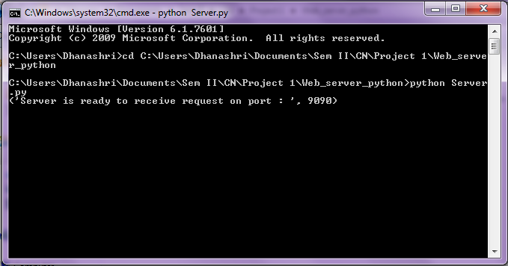



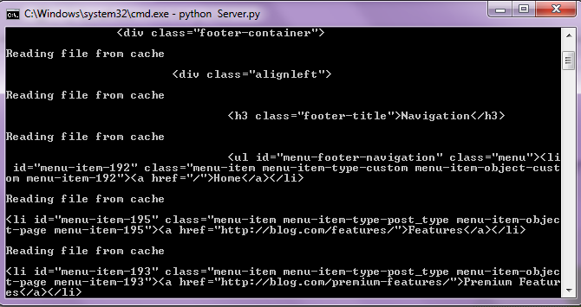

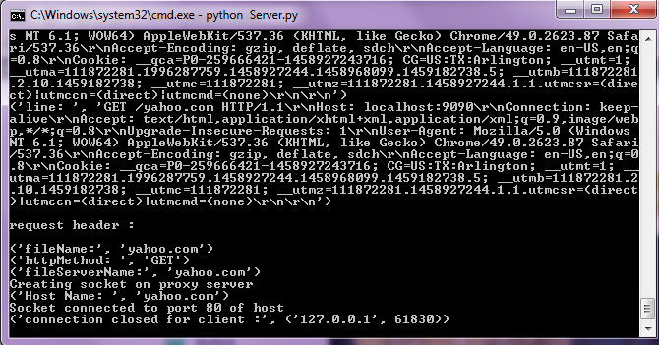

References:

<https://docs.python.org/2/>

<http://stackoverflow.com/>

<http://www.tutorialspoint.com/python/>